Web Application Development Log

Design Section

Project link on Github:
https://github.com/zed3538/signshow

Project name:
SignShow

Project Summary: Include purpose and target audience
SignShow is a sign language learning web app for people who want to learn New Zealand sign language. Language learning apps have been very popular over the years, but ones that include sign language are very rare, let alone New Zealand sign language. As one of the national languages of New Zealand, I believe more people should be encouraged to learn it.

Learn NZSL is an existing New Zealand sign language learning web app, but it does not have the same properties that typical language learning apps have—account creation, an algorithm for learned terms, etc.

I believe developing apps to learn more obscure languages will allow for closer connection between people who are native speakers and those who want to learn. In this case, native speakers may be those who are deaf, and their families.

Initial Database Design ERD:
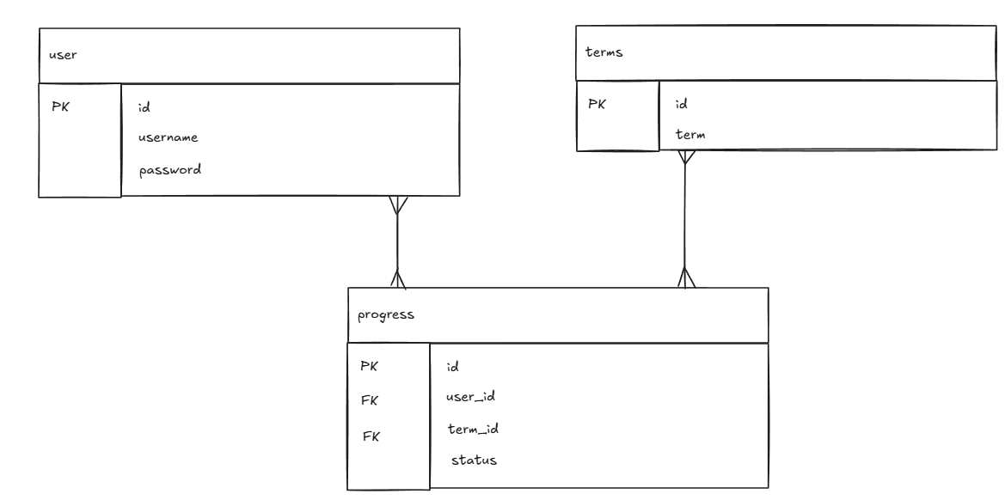

WebPage Design - Wireframe and/or Palette
WIREFRAMING

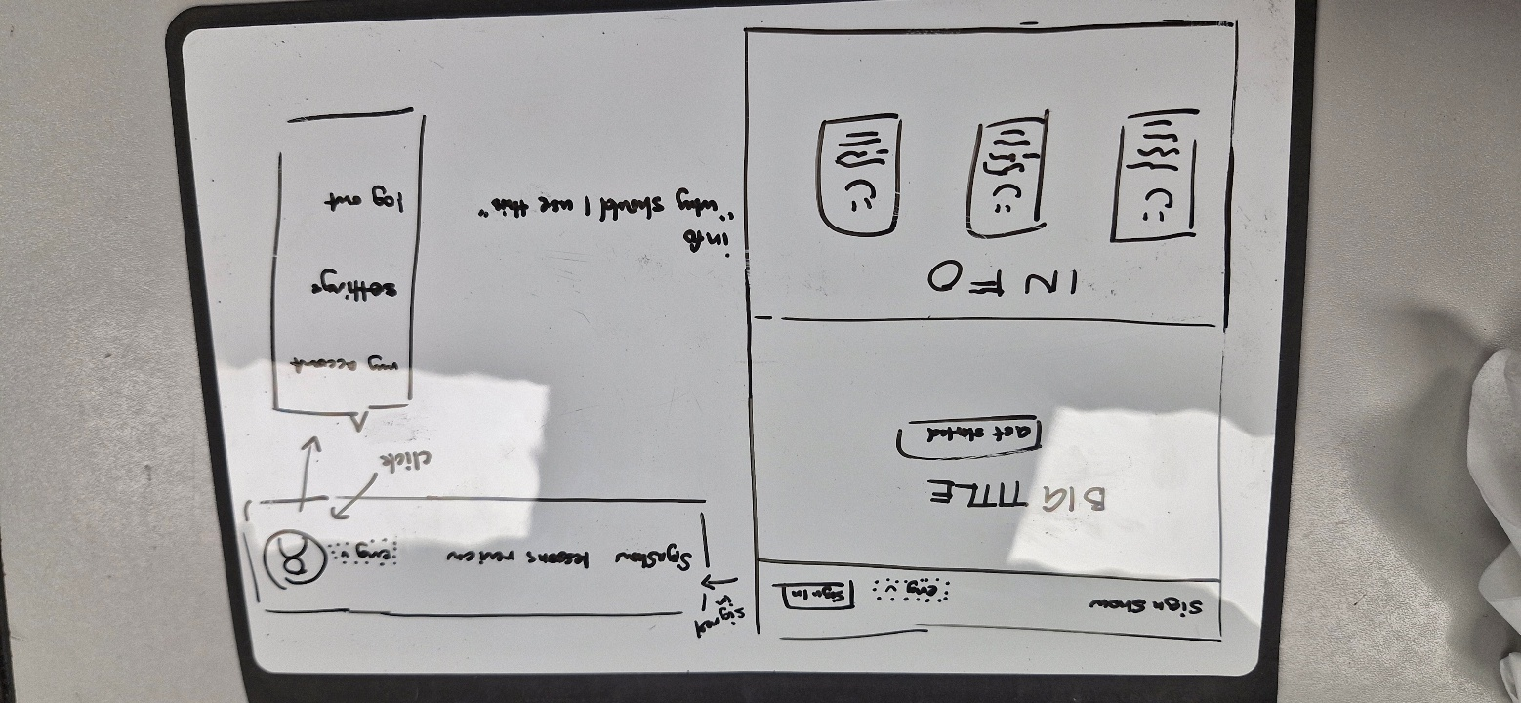
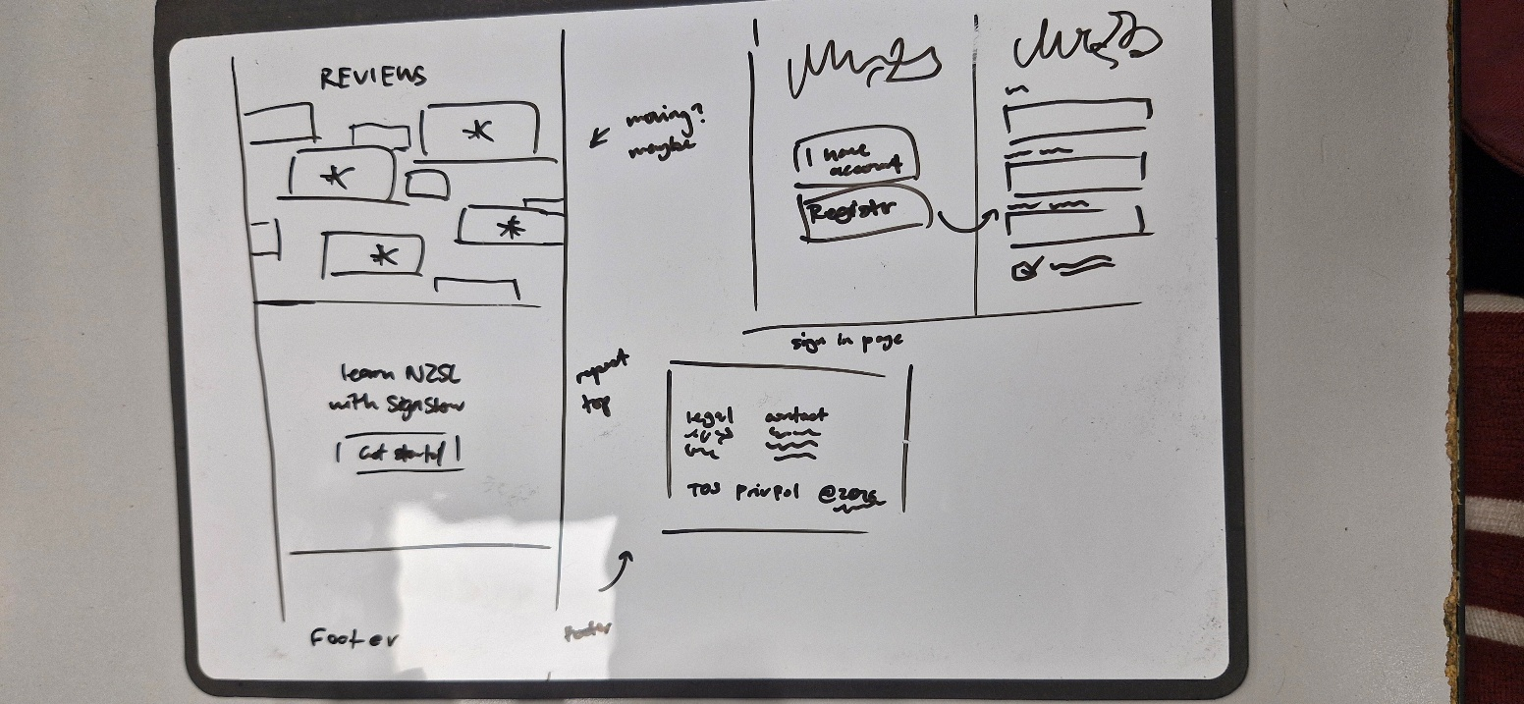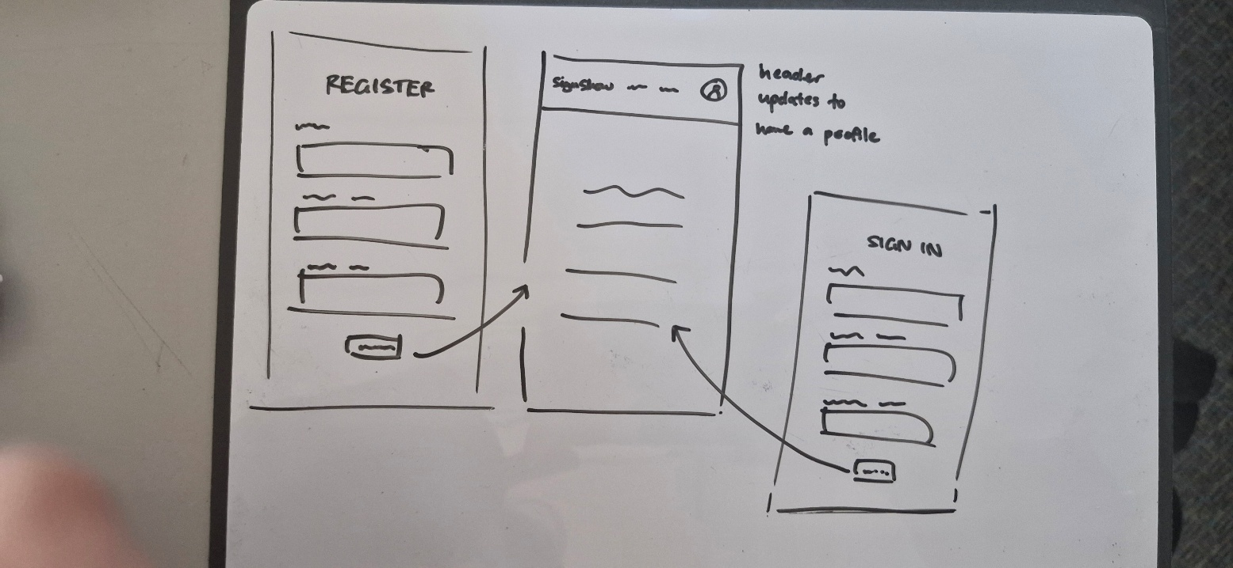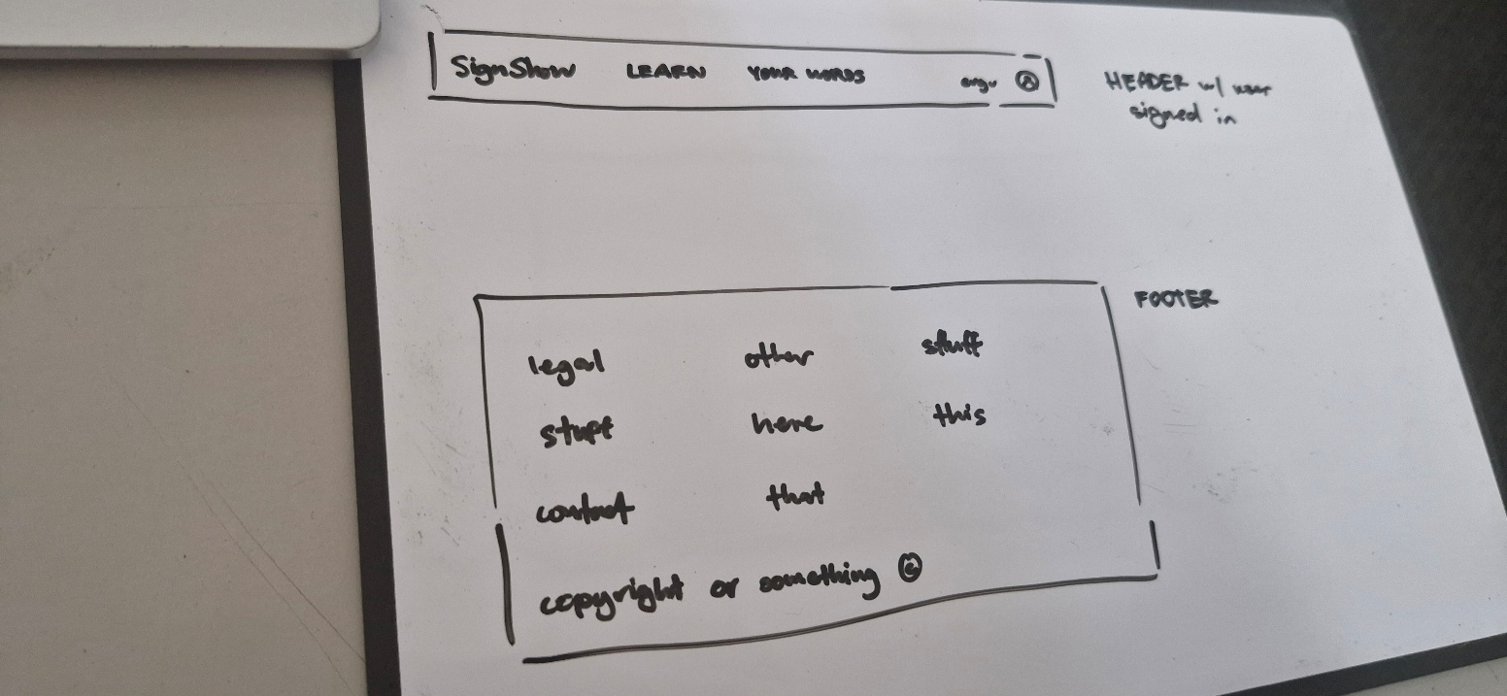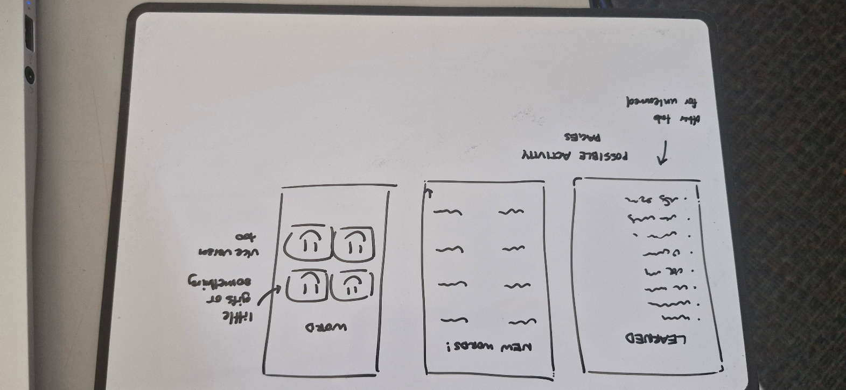

PALETTES

Palette | Pros | Cons | Palette with colour blindness | Pros | Cons
 | Nice contrast.  Colours are easy to differentiate, pleasing to the eye. | Colours may not be suitable for what I want. | 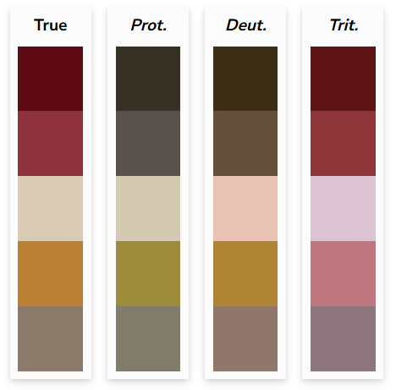 | Decent amount of contrast across all types. | Lighter red may need adjusting to be lighter for more contrast.
 | Good contrast.  Colours | There is a notable clash between the pink and blue, might not be the best. | 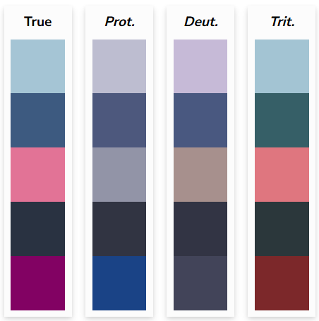 | Good contrast for most colours across all types. | Protanopia’s 2nd and 5th colours may blend in too much.
 | The contrast between the red and teal is good. | It looks a bit ugly. The teal stands out too much. | 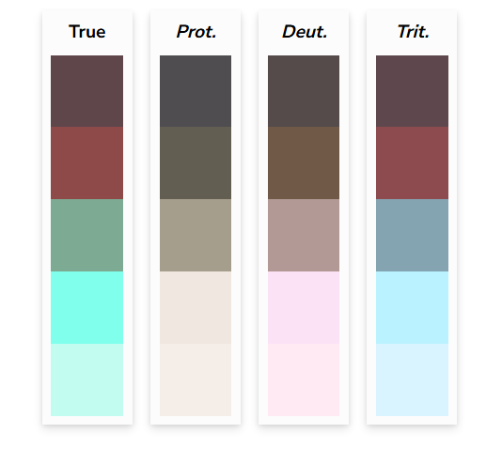 | Decent contrast. | The red and brown are hard to distinguish.  The teal and lighter teal are hard to see.
 | The colour scheme is nice on the eyes. | The blue is a bit bright compared to the rest of the colours. | 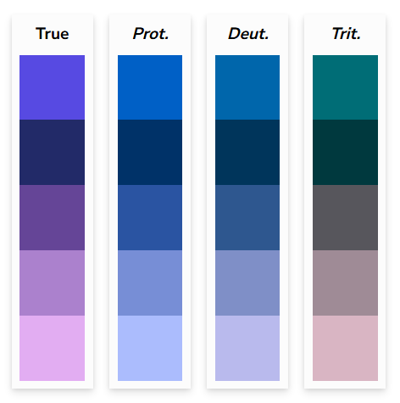 | Good variety of colours, visible across all types. | 1st and 3rd colours may
 | Contrast between the yellow and red is nice. | The two darker reds are a bit hard to see. | 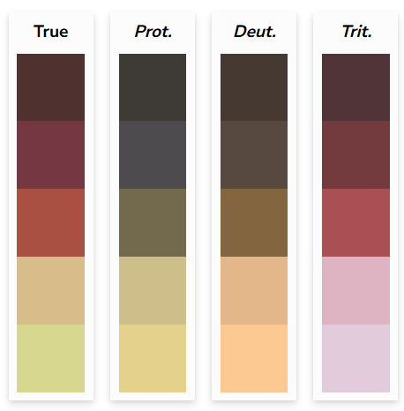 | Good variety of colours, looks alright for all types. | Might need more contrast for first and second colours.
 | The contrast is nice. | The blue is very off-putting. | 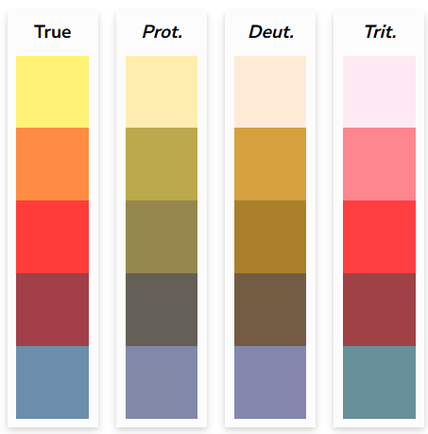 | Decently visible across all types. | Blue being off-putting is the same for all types.
 | I like the combination, good contrast. | Not a big variety of colours; limited palette. | 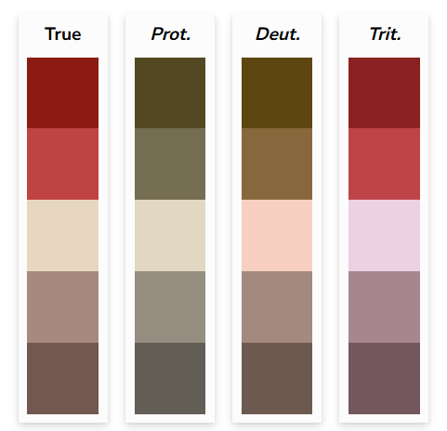 | Lots of contrast, looks good. | The two reds and two browns are a bit harder to see.
 | The difference between all shades is pleasing to the eye. | Combination and shades might resemble Duolingo too much. | 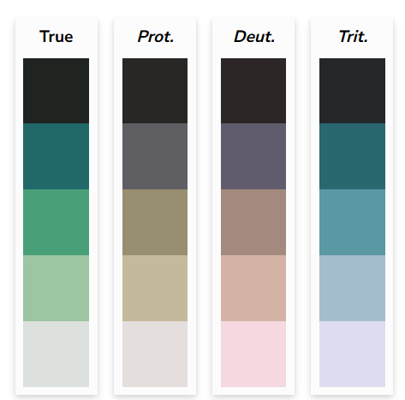 | Good across all forms of colour blindness. | The colours look a bit muddy and not what I envision for the project.

Relevant Implications (explain at least 3) - Before Development.
Privacy – Sensitive information must be dealt with accordingly in order to help prevent data from being leaked. Users entrusting their information to you means you must keep that data in your database safe. I will hash the users’ passwords in my database to ensure they are not leaked as plain text.

Usability – The interface must be able to convey the messages it needs to send appropriately and quickly, otherwise users will get confused. In the end, a functioning website means nothing if the interface prevents it from being appealing or understandable. I will be keeping my design simple to minimise visual clutter. I will also be keeping the colour palette and fonts consistent.

Accessibility – The application should be able to be used by all users. Measures such as applying alt text, ensuring colours have enough contrast, and taking note of other device screens can be taken to enhance accessibility. I will be tackling this by ensuring my colour palette is usable for all colourblind people by simulating what the different types would see. I will also be using alt text and ensure my font sizes are large enough so people who rely on screen readers or are visually impaired can use it too.

Sprint #1

Sprint #1 Goals
(before starting sprint 1):
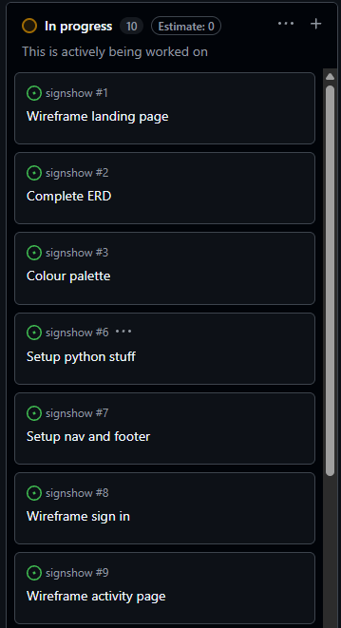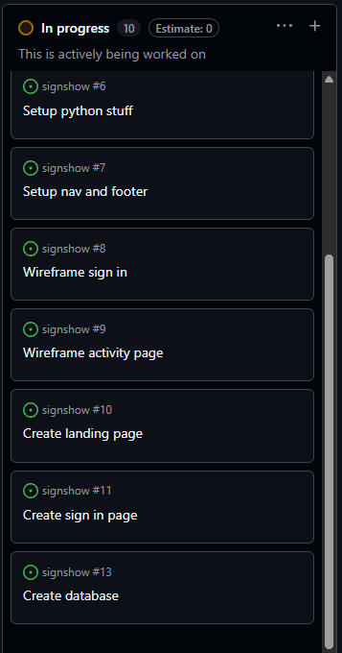

Sprint #1 Testing
Include tests for everything in your application including all links, input forms, correctness of data and correctness of queries. Add more columns as required.
Testing Table
What are you testing | How are you testing it | Expected Result | Pass/Fail
Card imports | Home page rendering |  | Fail
Login route page | Accessing the login page

Sprint #1 Review
Progress Review (100+ words)
I managed to get most of the landing page as well as the login page but is not functional at the moment. I still need to style the landing page to look better and more aesthetically pleasing. I did not get as far as I expected for this sprint as it took me quite some time to get used to using Flask, HTML, and CSS.

Sprint #2

Sprint #2 Goals
(before starting sprint):
- Functioning account system
- Style landing page
- Style signup and login pages
- Functioning routing across all pages

Database improvements (if any)
Entity Relationship Diagram

WebPage Design Improvements (if any)- Wireframe/Sketches/Pallette/Font etc

Sprint #2 Testing
Include tests for everything in your application including all links, input forms, correctness of data and correctness of queries. Add more columns as required.
Testing Table
What are you testing | How are you testing it/Input | Expected Result | Actual Result | Pass/Fail
Account creation (expected) 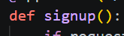 | jimbob123 | Account created in database | 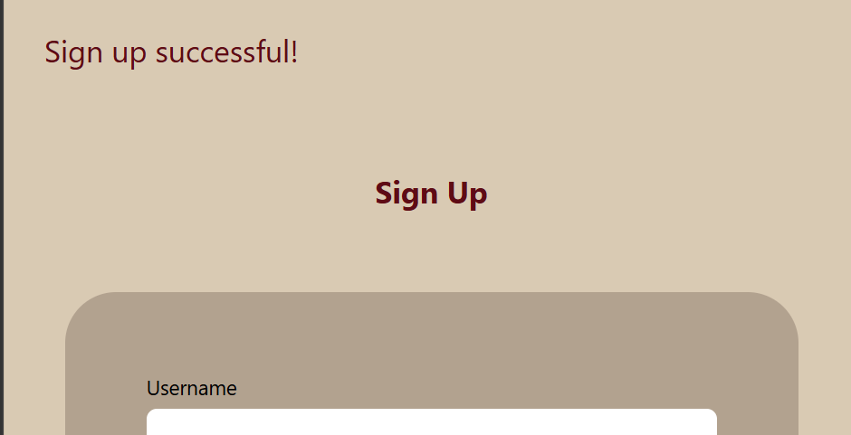 | Pass
 | register | Account created in database |  | Pass
Account creation (boundary) | 1010101 | Account created in database | 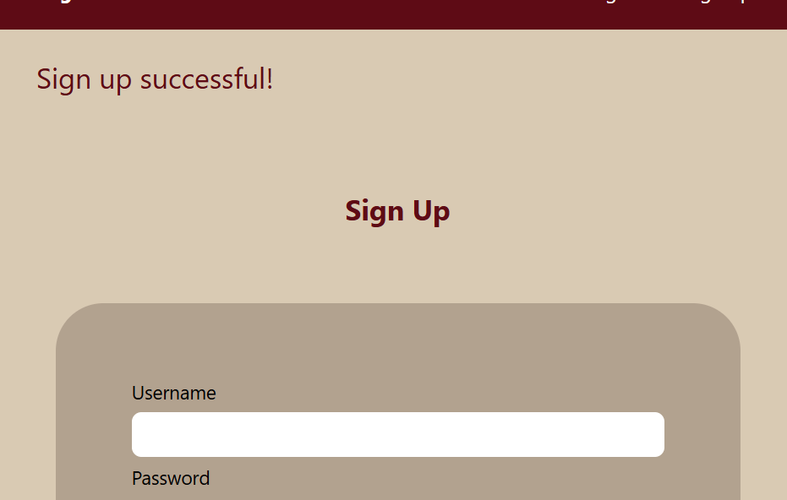 | Pass
 | a | Account created in database | 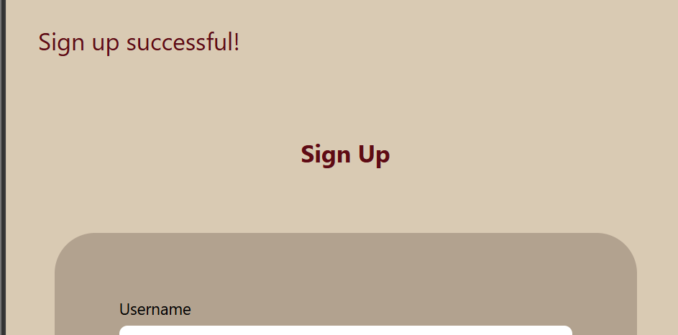 | Pass
Account creation (invalid) | ‘ ‘ (empty space) | Account not created in database | 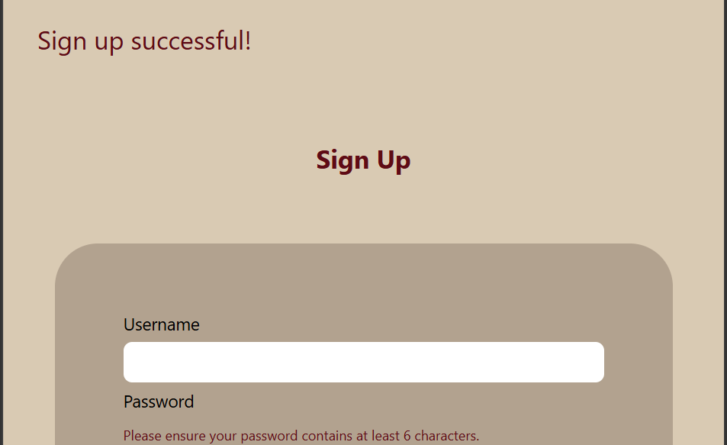 | Fail (account was created)
 | 327(##&! | Account not created in database | 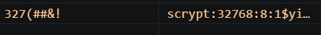 | Fail (account was created)

Sprint #2 Review
Progress Review (100+ words)
I think I did quite well this sprint. I managed to get all my goals done and have begun working on my ‘learn’ page for the core part of the website. My pages, which are working correctly when directed there, are all styled, but I do need to make some changes to the buttons. The account system mostly works as intended, but I now need to improve it by accounting for blank fields, invalid inputs with symbols and using it to query the database more. I also need to add a flash message for invalid registers and incorrect logins. I need to improve the styling by increasing some text sizes as they might be a bit small to cater for visually impaired people.

Sprint #3

Sprint #3 Goals
(before starting sprint):
- Dynamic routing for questions, error pages
- Improve security and requirements for account creation
- Improve styling to cater to more people
- Make quiz functional

Database improvements (if any)
Entity Relationship Diagram

WebPage Design Improvements (if any)- Wireframe/Sketches/Pallette/Font etc

Sprint #3 Testing
Include tests for everything in your application including all links, input forms, correctness of data and correctness of queries. Add more columns as required.
Testing Table
What are you testing | How are you testing it | Expected Result | Pass/Fail
Account creation (valid) | Username input: tester | 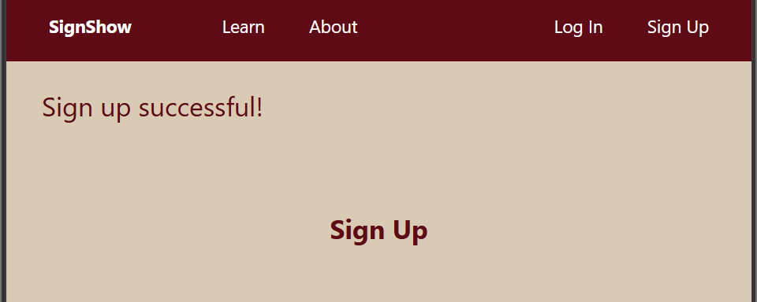 | Pass
Account creation (invalid) | Username input: guest 123 | 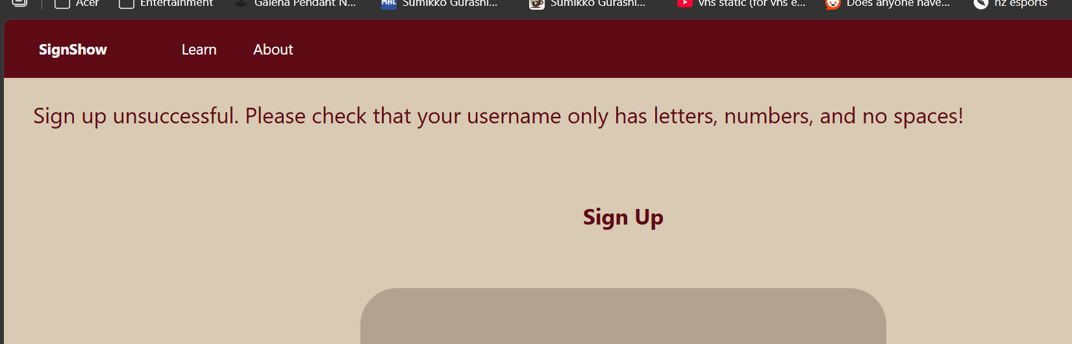 | Pass
Login (valid) | Username input: register  Password input: register |  | Pass
Login (invalid) | Username input: ‘ ‘ (blank space)  Password input: 123456 | 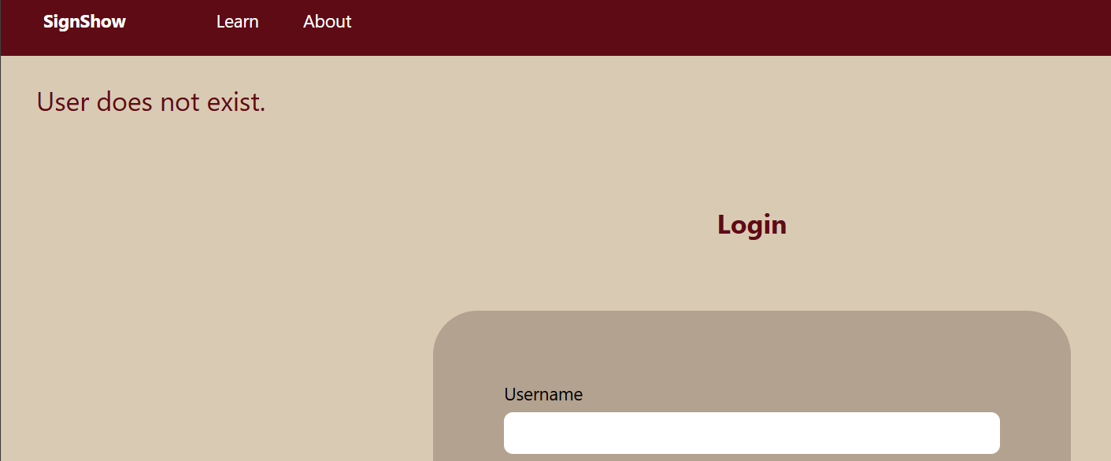 | Pass
Learn page | Going to the route | 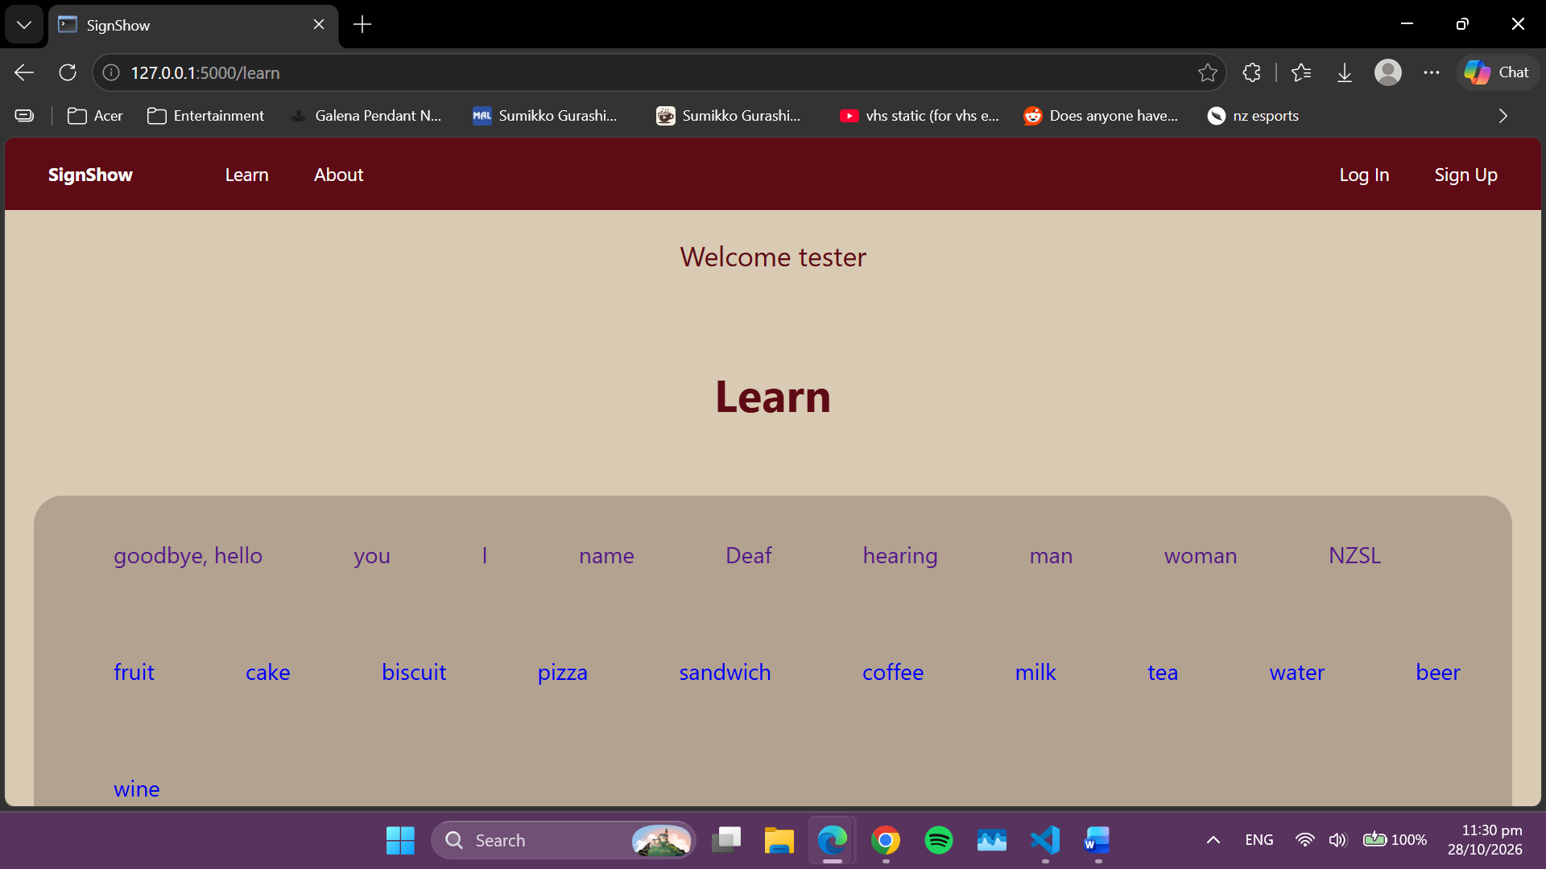 | Pass
Terms pages (dynamic routing) | Going to the route | 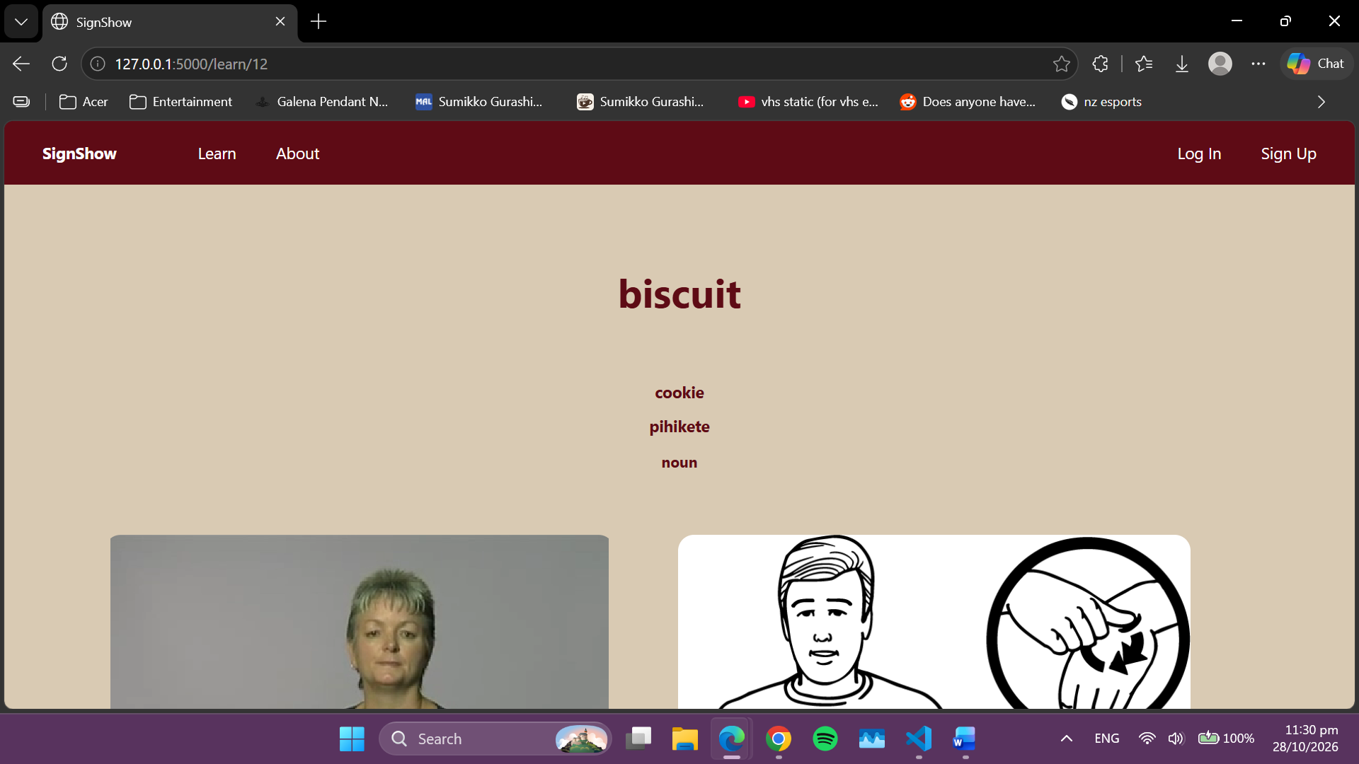 | Pass
Quiz questions | Clicking on correct and incorrect answers | 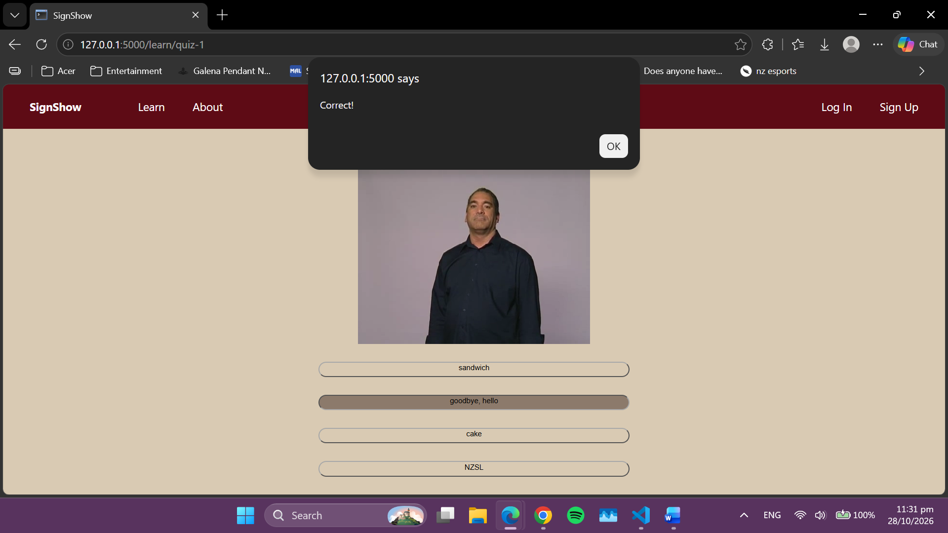 | Pass
New question | Clicking on correct answer | 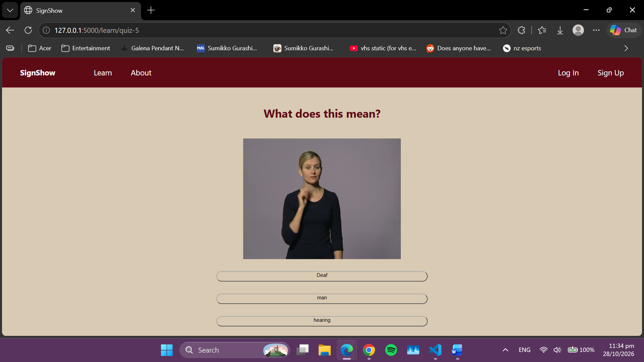 | Pass
404 page | Inputting incorrect link | 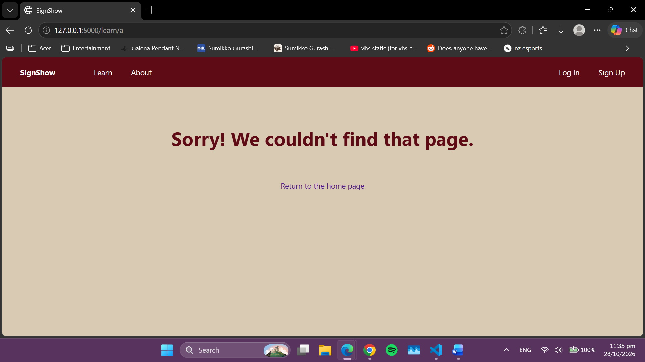 | Pass

Final Review
What were the results of your testing? Did you get through all that you expected to? What is causing problems? What went well? What was a challenge? What would you do differently if you had a chance?

Discuss how planning, testing and trialling led to the development of a high-quality digital technologies outcome.
My final testing went well. Everything functioned as expected, and invalid inputs were handled appropriately.

Unfortunately I did not get through all I expected to. I originally wanted to add an indication of progress for the user, but was unable to.

While I did change some aspects of my website, I mostly stuck to my original plan and managed to execute it. The interface is easy to navigate and users can move between pages to start a quiz without getting lost or encountering errors. Having a wireframe to refer back to allowed me to improve my website’s design. Planning my website meant I constantly had goals to work towards, even if I did change a few things. I ended up omitting half of the interface as I deemed some parts unnecessary for the website.

The biggest challenge I encountered was implementing the quiz functionality. Not only was I new to HTML, Flask, and SQL, I learned that I could use JavaScript quite late into the development. My initial idea was to use HTML buttons, but it was hard to implement interactivity with Python/Flask without JavaScript. This resulted in quite a lot of time spent on this one part of my website, which meant less time for other features to be added or refined.

Something I would do differently is

How I addressed the Relevant Implications
As discussed before the project, what relevant implications had you identified at the beginning and how did you manage to address them as you went. Were there any others that you came across while making this game? How did you manage to address them? 100+ Words

Marking Schedules: For Teacher use only

AS91902- Use complex techniques to develop a database

Credits: 4 (internal)
NZQA: https://www.nzqa.govt.nz/nqfdocs/ncea-resource/achievements/2019/as91902.pdf

Achieved- develop a database | Evidence | ✔
designing the structure of the data | Made an ERD with at least ONE MANY-TO-MANY relationship before the end of the project.
using appropriate tools and advanced techniques to organise, query and present data for a purpose and end users | Competently normalized data structure  Multiple queries across linked tables  Basic Python CRUD functionality with text input/output
applying appropriate data integrity and testing procedures | Testing Logs. Do the queries work and return what is expected?
addressing relevant implications. | the application meets key relevant implications like copyright, IP (correctly sourced and attributed imagery), Privacy (eg passwords hashed) etc. May have highlighted this in final Relevant Implications Task
Merit- Develop and informed database
using information from testing procedures to improve the quality of the outcome | Suggested improvements implemented- improve database design, add or refine entities or tables and relationships  Made improved ERD(s)
structuring, organising and querying the data logically | No problems with structure and datatypes in the table. No wildcard queries, JOIN’s used efficiently.  2NF at least.
Excellence- develop a refined database
iterative improvement throughout the design, development and testing process | Improved functionality of database and refinements to structure of the data.
using efficient tools and techniques in the outcome’s production | Effectively used Version Control, extensions or tools (like sqlitestudio) and VSCode.
presenting the data effectively for the purpose and end users. | Very refined outcome providing all needed functionality

AS91903 - Use complex techniques to develop a digital media outcome
Credits: 4 (Internal)
NZQA: https://www.nzqa.govt.nz/nqfdocs/ncea-resource/achievements/2019/as91903.pdf

Achieved | Evidence
applying appropriate tools and techniques to meet the purpose and end users requirements | Coded a website in HTML and CSS. Looks and functions mostly like intended in the design.
applying appropriate data integrity and testing procedures | It functions as intended and the right pages show with the correct data when the links are clicked
Applying user experience principles relevant to the purpose of the outcome | Site has good usability (HCI)
addressing relevant implications. | the application meets key relevant implications like copyright, IP (correctly sourced and attributed imagery), Privacy (eg passwords hashed) etc. May have highlighted this in final Relevant Implications Task
Merit
using information from testing procedures to improve the quality of the outcome | Testing and sprint reviews show evidence of specific improvement made based on the testing. No lorem ipsum anymore!! Accurate Data
applying user experience principles to improve the quality of the digital media outcome. | Good HCI. Eg. generally shows “consistency and standards”, and/or “help and documentation” by having an about page. No “annoyances”
Excellence
iterative improvement throughout the design, development and testing process to produce a high-quality outcome | Must be high quality. No obvious errors or inaccurate data.
using efficient tools and techniques in the outcome’s production. | Kept a good log, used github to keep backups and record of work, lots of commits on github.

AS91906 - Use complex programming techniques to develop a computer program

Credits: 6 (Internal)
NZQA: https://www.nzqa.govt.nz/nqfdocs/ncea-resource/achievements/2019/as91906.pdf

Achieved | Evidence
writing code for a program that performs a specified task | Applications works as intended.
using complex techniques in a suitable programming language | “programming or writing code for a graphical user interface (GUI)” flask requires that  “reading from, or writing to, files or other persistent storage ”- the sqlite file  “using additional non-core libraries”- using Flask.
setting out the program code clearly and documenting the program with comments | Some code comments, code layed out relatively cleanly with constants/variable at the top, routes and functions after.
testing and debugging the program to ensure that it works on a sample of expected cases. | Testing table shows the basic web page functionality was tested.
Merit
documenting the program with appropriate names and organised comments that describe code function and behaviour | Good variable and function names. Good and plentiful code comments.
following conventions for the chosen programming language | PEP8 Followed. Use Pylint or similar and check linting.
testing and debugging the program effectively to ensure that it works on a sample of both expected cases and relevant boundary cases. | Lots of testing including request for non-existent id returning an error 404 page.
Excellence
ensuring that the program is a well-structured, logical response to the specified task | Enhanced program, e.g. functions that aren’t routes to make the code cleaner (eg query_db). Neat and logical code.
making the program flexible and robust | Great structure making code easy to extend. Unbreakable code. Eg. Error-404 and error 505 handlers
comprehensively testing and debugging the program. | Unbreakable code with a lot of tests done for every testable element of the program including unexpected input like a non existent route or page returning custom error 404 handler

